**WEEK 1**

**Task-1**

**Aim**: How to download and install JAVA software.

Procedure:

STEP 1: Go to browser and search for java download

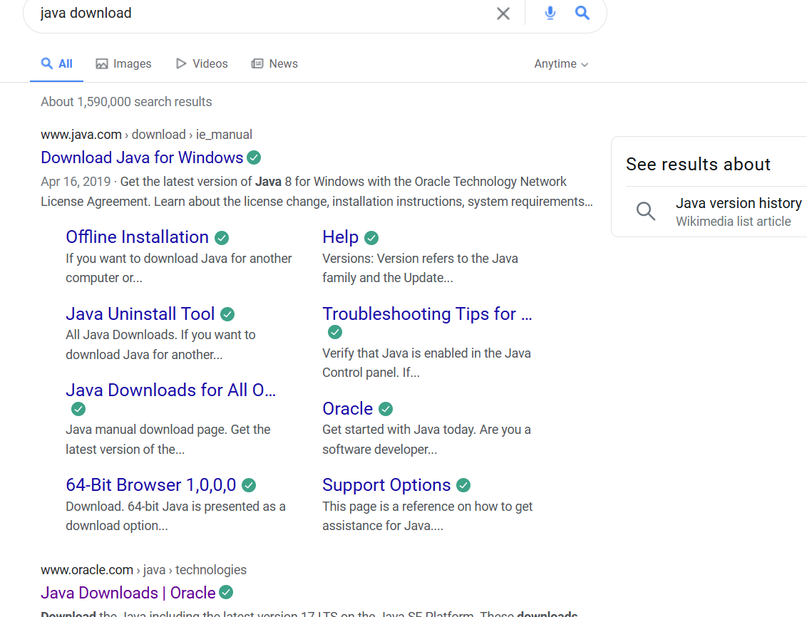

Step2: Open website link with oracle

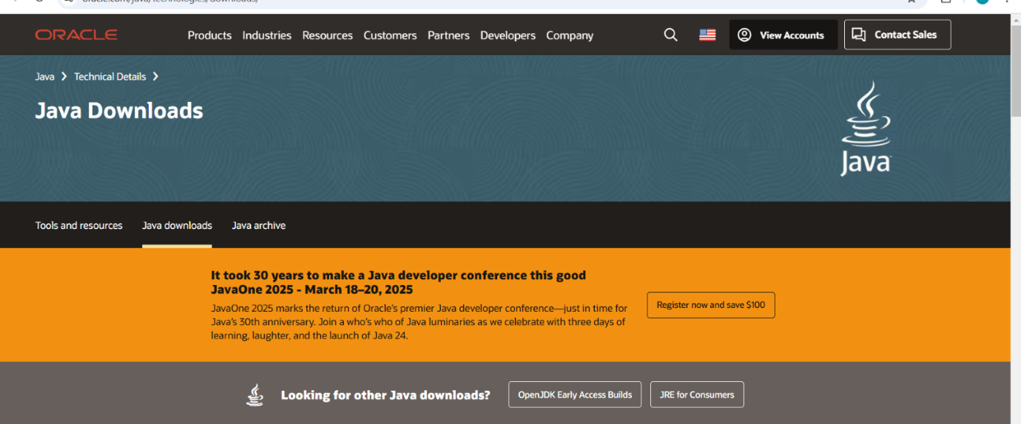

Step3: Click on JDK 21 and click on windows

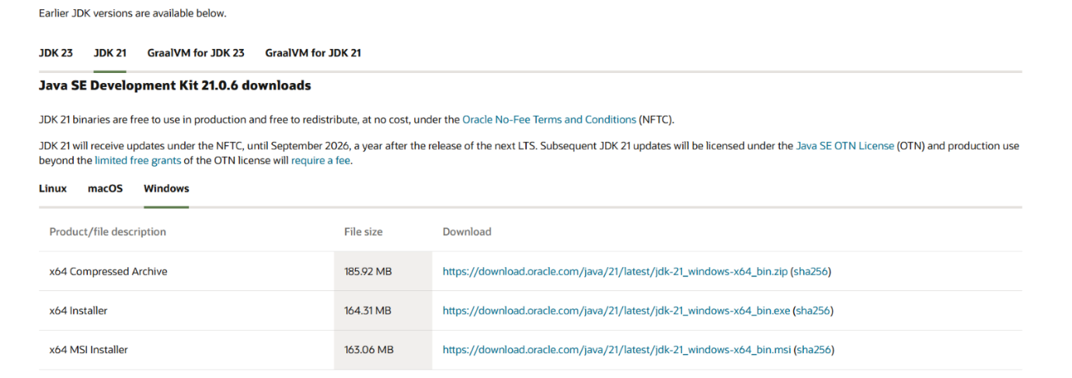

Step4: After that click on x64 installer

Step5: The download starts

Step6: After downloading the next step installation starts

Step7: After installation we need to set a path

Step8: Go to “c” drive in c drive we must the program files

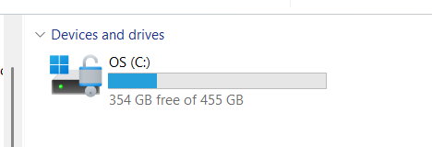

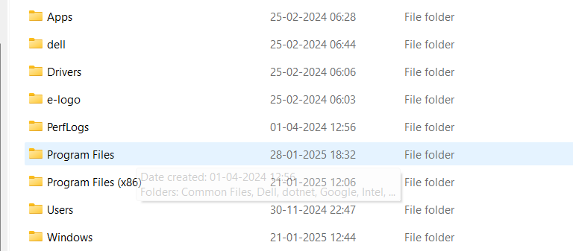

Step 9: Double click on the program files and double click on the java

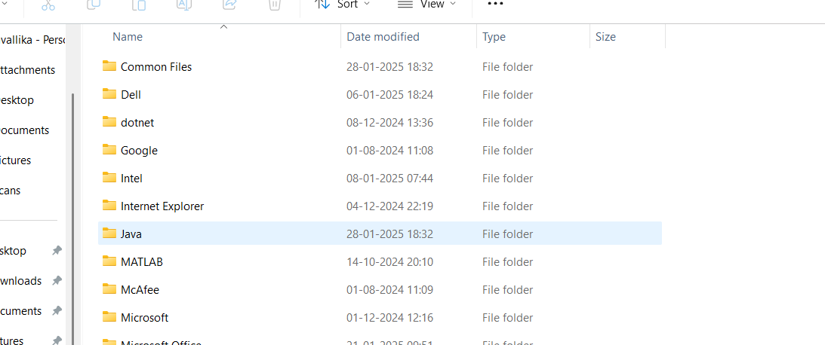

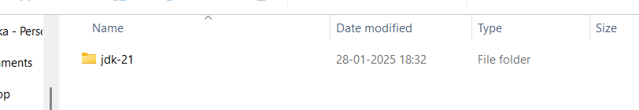

 Step 10: Click on JDK-21 and select bin

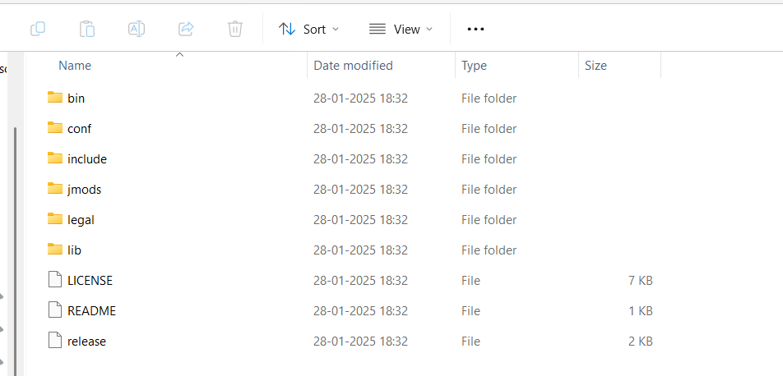

Step11: Copy the link and paste the environment

Step12: Select the system variables and select the path

STEP13: After selecting the path we need select new one need to paste the link

Step14: After pasting the link we need to click the ok and the apply

Step15: In this way the downloading and installation of java takes place

Step16: After installation go to command prompt and type javac –version

Step17: In command prompt we get the version which we download.

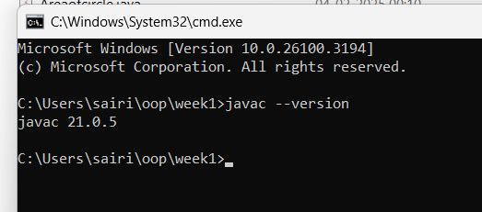

**Task-2**

**Aim:** Write the java program to print the message “welcome to java programming “

Code:

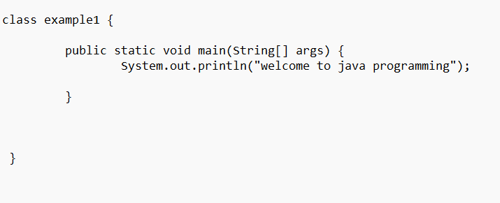

Output:

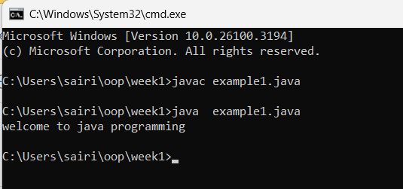

**Task-3:**

**Aim**: write the java program to print the message “Name, class, roll.no, section”.

Code:

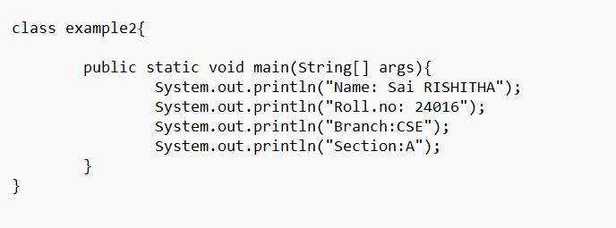

Output:

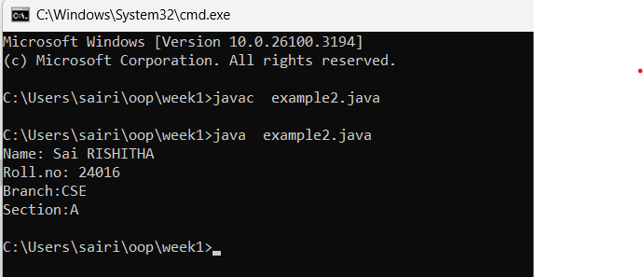

**Week-2**

**Task-1**

**Aim:** write a java program to calculate the area of the rectangle

Input code:

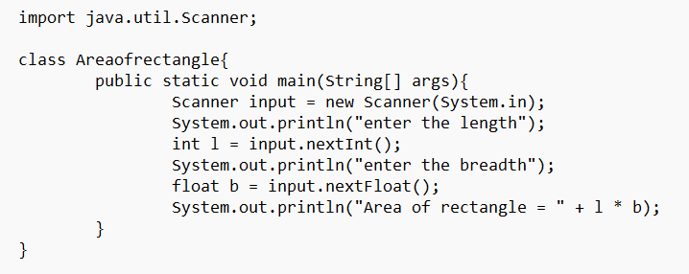

Output:

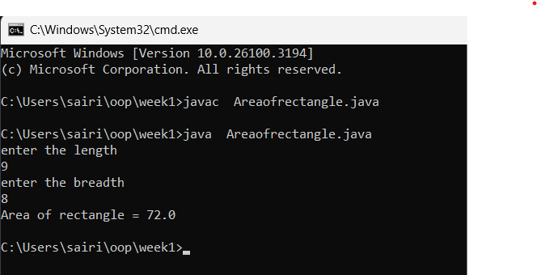

ERROR:

|  |  |  |
| --- | --- | --- |
| SI.NO | Error message | Error rectification |
| 1. | Error: file not found | “rectangle” |
| 2 | Error: incorrect formula | Rewrite formula |

**Task-2:**

**Aim:** write a java program to convert temperature from Celsius to Fahrenheit.

Input Code:

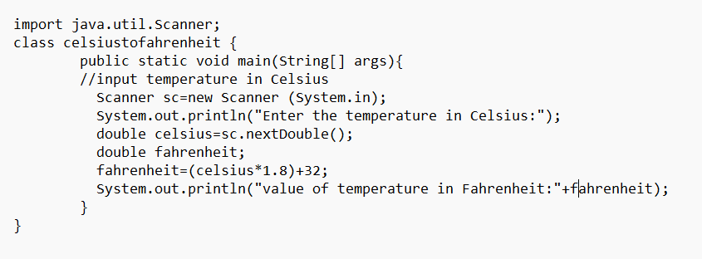

Output:

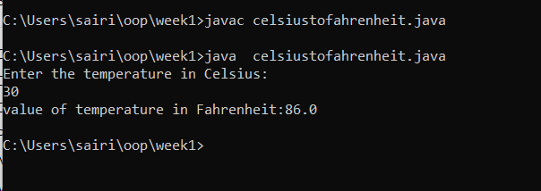

Error

|  |  |  |
| --- | --- | --- |
| SI.NO | Error message | Error rectification |
| 1 | Error: expected | Inserted; |
| 2 | Error: scanner input” capital letter case sensitive” | “Scanner input” |

**Task-3**

**Aim:** write a java program to calculate the simple interest

Code:

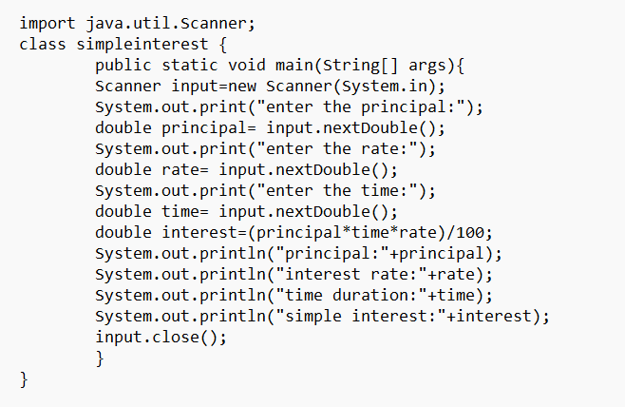

Output:

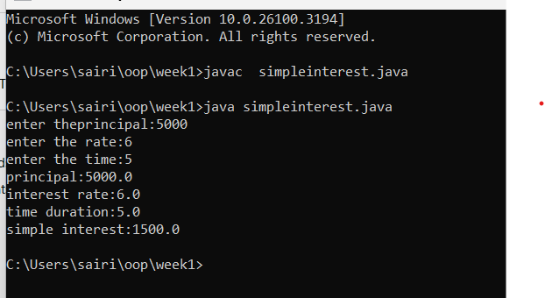

Error

|  |  |  |
| --- | --- | --- |
| SI.NO | Error message | Error rectification |
| 1 | Error: input nextInt[]”parenthesis” | “input nextInt()” |
| 2 | Error: ”Scanner object not closed” | Placed paranthesis[] |

**Task-4**

**Aim:** Write a java program largest of three number using ternary operator .

Input code:

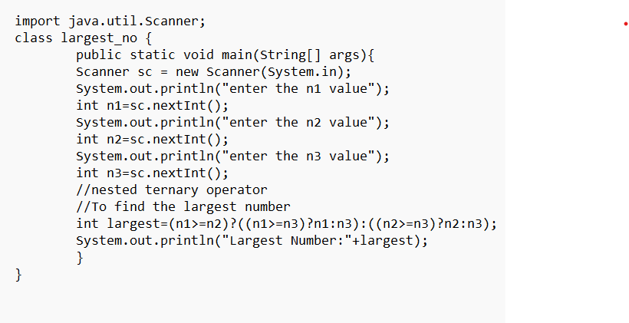

Output:

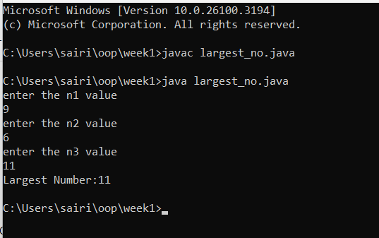

Error

|  |  |  |
| --- | --- | --- |
| SI.NO | Error message | Error rectification |
| 1 | Error: ”variable i not   declared properly” | Declared inside the loop |
| 2 | Error: ”access modifier for class” | Public class simple |

**Task-5**

**Aim:** Write a java program to find the factorial of number.

Input code:

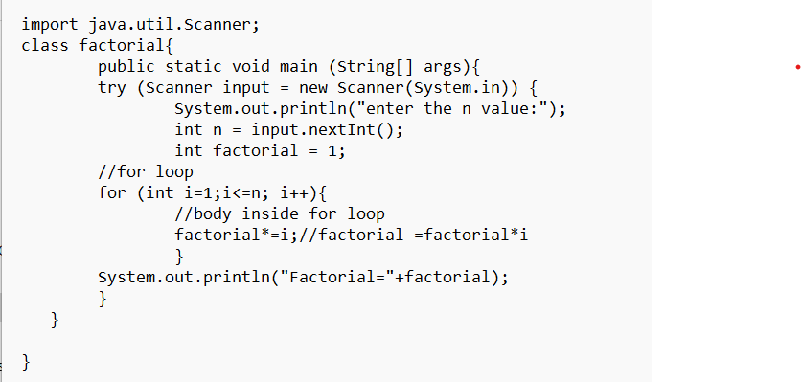

Output:

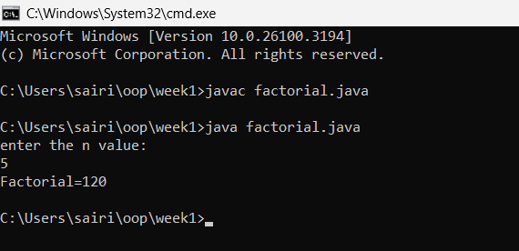

Error

|  |  |  |
| --- | --- | --- |
| SI.NO | Error message | Error rectification |
| 1 | Error: ’file not found’ fact | ‘fact’ |
| 2 | Error: expected”;” | Inserting’;’ |